## ABSTRACT

This project presents a low-cost, Arduino-based **Human Following Robot** named *QuantumDrift*. The robot is designed to detect, track, and follow a human using **ultrasonic** and **infrared (IR)** sensors. The robot uses an **Arduino Uno** as its brain, along with a **servo motor** for scanning, **IR sensors** for position detection, and **DC motors** for movement. The robot adjusts its path in real time to maintain a safe distance from the person. The aim of this project is to explore sensor integration, autonomous navigation, and motor control in a simple yet practical robotics application.

# Chapter I: Introduction

## Introduction

Human-following robots are increasingly popular in fields like personal assistance, warehouse automation, and surveillance. Our project, *QuantumDrift*, uses affordable electronics to create a robot that follows a human by interpreting distance and directional signals from sensors.

## 1.1 Objectives

1. To design and build a **low-cost human-following robot** using Arduino.
2. To integrate **ultrasonic and IR sensors** for human detection and tracking.
3. To control DC motors using **motor drivers** and program logic.
4. To gain hands-on experience in **Arduino programming** and sensor control.

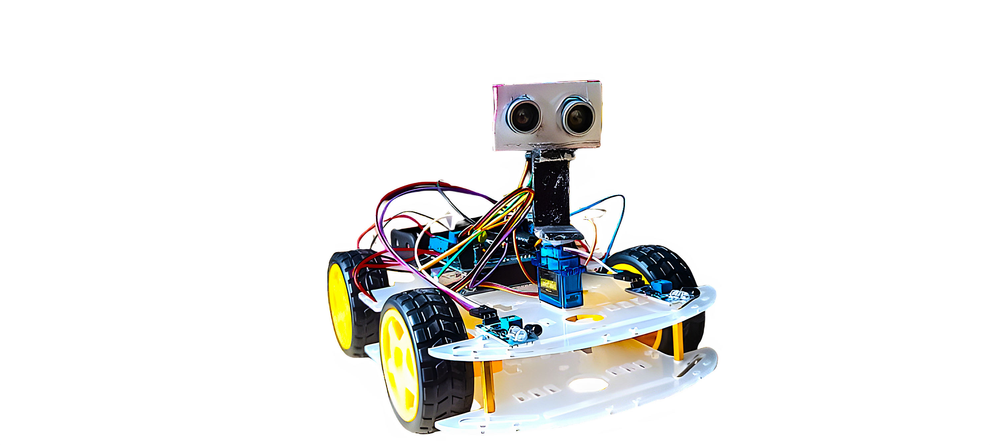

FIG 1.1 Human Following Robot

The fig 1.1 depicts the pic of our model.

## 1.2 Layout

Fig1.2 Flowchart of Model

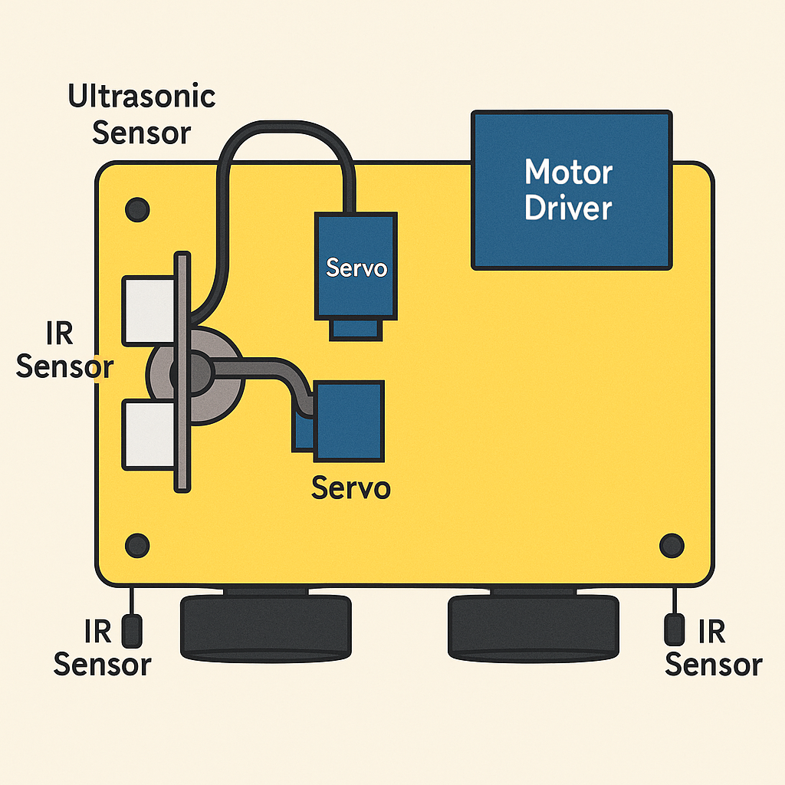

The fig 1.2 depicts the flowchart of the model.

# Chapter II: Review on Existing Literature

## Literature Survey

Robotics systems that follow humans have been a topic of research for many years. Several studies and projects have explored the use of sensors, microcontrollers, and motor drivers to implement such intelligent robots.

One of the earliest approaches involves using infrared (IR) sensors to detect the presence of a human. However, IR sensors alone were found to be unreliable in bright environments due to interference from sunlight or artificial lighting. Later, ultrasonic sensors were introduced, offering better accuracy in distance measurement and obstacle avoidance.

In a 2016 study, researchers built a human-following robot using Arduino Uno and ultrasonic sensors mounted on a servo motor to scan the surroundings. The robot could track a person within a specific range and adjust its movement accordingly. The main challenges they encountered were sensor accuracy, smooth movement, and battery management.

A separate project used a combination of IR sensors and a camera module with image processing via Raspberry Pi. Although this provided more advanced tracking, the cost and complexity were significantly higher than Arduino-based solutions.

An innovation by students at IIT Kanpur used PID control with IR sensors and encoders for precise tracking. However, it required complex calibration and programming skills.

Another approach included Bluetooth or RFID to track a person carrying a tag. Though useful in indoor environments, this technique lacks adaptability and real-time direction sensing.

## 2.1 Arduino Uno

The **Arduino Uno** is an open-source microcontroller board based on the **ATmega328P**. It is widely used in educational and hobby robotics projects due to its simplicity, low cost, and extensive community support. The board includes 14 digital input/output pins, 6 analog inputs, a USB connection, and a power jack.

In the context of the human-following robot, the Arduino Uno acts as the **brain of the system**, processing sensor data from the **ultrasonic sensor**, **IR sensors**, and controlling the motors via motor **driver (L298N)**. It runs a pre-programmed sketch (code) that determines how the robot reacts to sensor inputs, enabling autonomous human tracking and obstacle avoidance.

## 2.2 Sensor Integration

To track a human effectively, the robot relies on two main types of sensors:

1. Ultrasonic Sensor (HC-SR04): Measures distance using ultrasonic sound waves. It sends out a pulse and listens to the echo to calculate how far an object is. Mounted on a servo motor, it scans the area in front of the robot.
2. Infrared (IR) Sensors: These detect whether the person is on the left, right, or center. They work based on the reflection of IR light. When an object comes in close range, the sensor detects the reflected signal and sends data to the Arduino.

By combining these sensors, the robot can decide whether to move forward, turn left, right, or stop completely.

## 2.3 Motor Control and Power

1. The L298N motor driver module is used to drive two DC motors. It receives logic-level signals from the Arduino to set direction and speed using PWM (Pulse Width Modulation).
2. A LiPo battery (7.4V, 2200mAh) powers the robot. Proper voltage regulation is crucial to avoid underpowering motors or overheating components.

## 2.4 Comparison Table of Key Technologies

Table 2.1: Comparison Table of Key Technologies

| **Feature** | **Arduino Uno** | **Raspberry Pi** | **NodeMCU (ESP8266)** |
| --- | --- | --- | --- |
| Type | Microcontroller | Minicomputer | Microcontroller + WiFi |
| Coding Language | C/C++ | Python, C++ | C/C++, Lua |
| GPIO Pins | 14 Digital, 6 Analog | 26+ | 11+ |
| WiFi Support | No (needs module) | Yes (built-in) | Yes (built-in) |
| Cost | Low (~₹400) | High (~₹3000) | Very Low (~₹250) |
| Suitability | Ideal for sensor/motor control | Good for AI/image processing | Great for IoT projects |

Table 2.1 explains the Comparison Table of Key Technologies

## Conclusion:

For our project, Arduino Uno was selected due to its simplicity, real-time control, and community support for beginners in robotics.

# Chapter III: Work, Results and Analysis

## 3. Work Done

Fig 3.1 Working procedure of the model

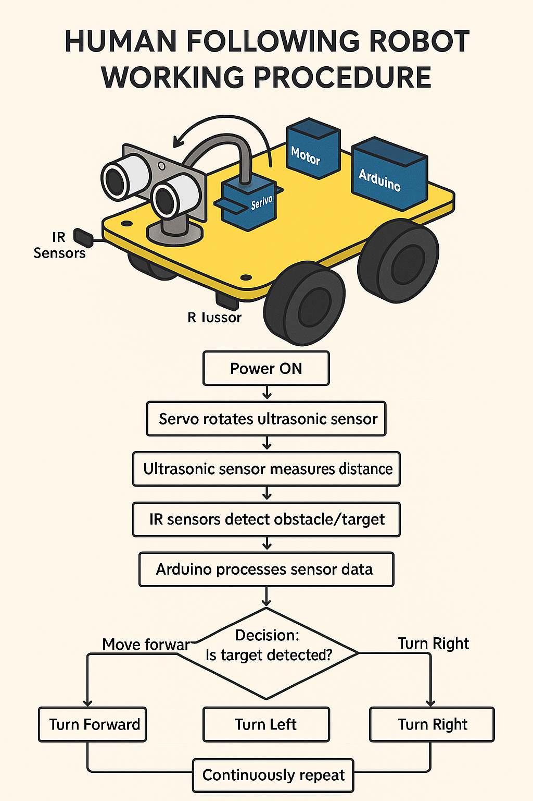

The fig 3.1 depicts the working of the model

The Human Following QuantumDrift was developed through a series of well-defined steps that involved component selection, mechanical design, sensor integration, programming, and testing. The goal was to make a robot that detects and follows a human using ultrasonic and IR sensors.

## Step-by-Step Process:

1. **Component Selection**  
   Collected all necessary components: Arduino Uno, HC-SR04 ultrasonic sensor, IR sensors, servo motor, L298N motor driver, LiPo battery, wheels, chassis.

**Mechanical Assembly**

* 1. Chassis was built with wheels and motors mounted.
  2. Ultrasonic sensor fixed on top of the servo for rotating scan.
  3. IR sensors mounted on left and right sides.
  4. Arduino and motor driver placed at the center.

1. **Circuit Connections**
   1. DC motors wired to the **L298N driver**.
   2. Sensors and servo connected to Arduino digital pins.
   3. Powered using **7.4V LiPo battery** for motors and **5V from Arduino** for sensors.
2. **Programming the Arduino**
   1. Libraries used: **AFMotor**, **NewPing**, and **Servo**.
   2. Logic included:
      1. Scanning with ultrasonic sensor using servo.
      2. Detecting human position (left, right, front) with IR sensors.
      3. Sending motor commands to follow the person.
3. **Testing & Calibration**
   1. Adjusted IR thresholds.
   2. Tuned ultrasonic sensor delay and servo angle.
   3. Checked stability under various lighting and motion conditions.

## 3.1 Circuit Diagram

1. **Ultrasonic sensor**: Connected to Trig and Echo pins of Arduino.
2. **IR sensors (left and right)**: Connected to digital pins.
3. **Servo motor**: Connected to a PWM pin.
4. **L298N motor driver**: Connected to 4 digital pins from Arduino for motor control.
5. **Battery**: LiPo 7.4V connected to motor driver; sensors powered via Arduino

FIG 3.2: Circuit Diagram

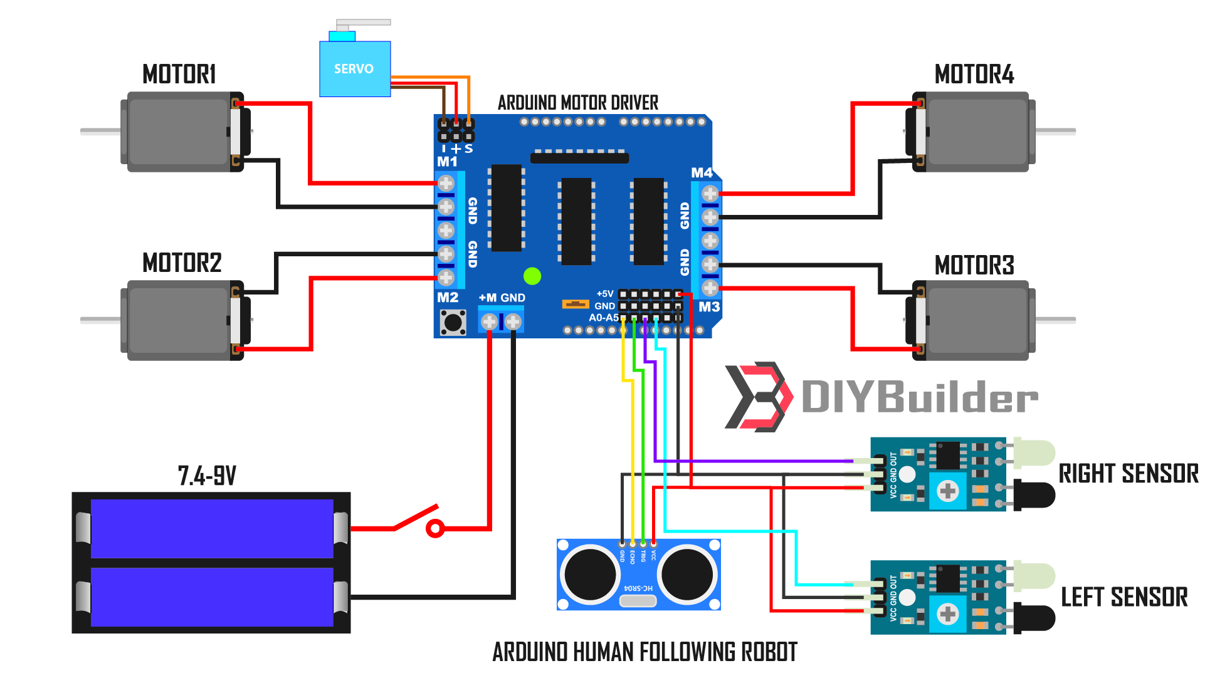

The fig 3.2 is a circuit diagram of our model.

## 3.2 Results and Observations

Table 3.1: Results and Observations

| Test Condition | Expected Output | Actual Result |
| --- | --- | --- |
| Person in front | Move forward | Followed correctly |
| Person on the left | Turn left | Responded correctly |
| Person on the right | Turn right | Turned accurately |
| No person detected | Stop | Stopped as expected |
| Obstacle close (<10 cm) | Stop | Collision avoided |
| Power supply check | Smooth motor operation | Stable with LiPo |

The table 3.1 shows the results and observations recorded.

## 3.3 Analysis

1. The robot successfully followed a human indoors within a range of 10–40 cm.
2. The servo-mounted ultrasonic sensor helped increase the detection range.
3. IR sensors accurately detected left/right position but struggled under very bright light.
4. Power stability improved by switching from 9V battery to LiPo 7.4V 2200mAh.
5. Robots performed best in indoor environments with medium lighting.

Top of Form

**Bottom of Form**

# Chapter IV: Conclusion & Future Scope

## 4. Conclusion

The project successfully demonstrates the design and implementation of a low-cost human-following robot using Arduino Uno, ultrasonic sensor, IR sensors, and servo motor. The robot can detect a human within a specified distance range and autonomously follow them by adjusting its movement in real time.

The ultrasonic sensor, mounted on a servo motor, provides dynamic scanning, while IR sensors detect the direction of the target. Motor control is managed via an L298N driver module, and the entire system is powered by a LiPo battery for stable performance. The robot was tested in indoor conditions and showed accurate tracking, smooth movement, and effective obstacle avoidance.

This project helped the team gain practical experience in microcontroller programming, sensor calibration, circuit integration, and autonomous robotics — providing a solid foundation for more advanced robotic applications in the future.

## 4.1 Future Scope

1. **Outdoor Use:** Improve sensor calibration and add shielding to IR sensors for better outdoor performance.
2. **Advanced Tracking:** Use camera modules (e.g., OpenCV with Raspberry Pi) for face detection and advanced object tracking.
3. **Obstacle Avoidance:** Add additional ultrasonic or IR sensors on the sides and back for full 360° obstacle detection.
4. **Auto Recharge Dock:** Add a system for the robot to return to a charging dock when low on power.
5. **Speed & Stability:** Upgrade motors and chassis design for better balance, speed, and surface coverage.

## References

1. Pal, A., 2011. *Microcontrollers: Principles and Applications*. PHI Learning Pvt. Ltd..
2. Kumar, K.A. and Dhadge, O., 2018. A novel infrared (ir) based sensor system for human presence detection in targeted locations. *International Journal of Computer Network and Information Security*, *10*(12), pp.34-40.
3. Ishak, N.H., Zainodin, M.N., Salim, N.A., Twon Tawi, F.M. and Mohd Saod, A.H., 2015. A design of an automatic single phase power factor controller by using Arduino uno Rev-3. *Applied Mechanics and Materials*, *785*, pp.419-423.
4. Ambikapathy, A., Sandilya, J., Tiwari, A., Singh, G. and Varshney, L., 2020, March. Analysis of Object Following Robot Module Using Android, Arduino and Open CV, Raspberry Pi with OpenCV and Color Based Vision Recognition. In *International Conference on Emerging Trends and Advances in Electrical Engineering and Renewable Energy* (pp. 365-377). Singapore: Springer Nature Singapore.
5. Zhmud, V.A., Kondratiev, N.O., Kuznetsov, K.A., Trubin, V.G. and Dimitrov, L.V., 2018, May. Application of ultrasonic sensor for measuring distances in robotics. In *Journal of physics: conference series* (Vol. 1015, No. 3, p. 032189). IOP Publishing.
6. Gandla, M.T., 2021. Human Following Robot. *Available at SSRN 3917847*.
7. TutorialsPoint, “IR Sensor Interfacing with Arduino,” [Online].

Available: <https://www.tutorialspoint.com/ir-sensor-interfacing-with-arduino>

1. Instructables, “Human Following Robot using Arduino,” [Online].

Available: https://www.instructables.com/Human-Following-Robot-Using-Arduino/

1. Datasheet – HC-SR04 Ultrasonic Sensor. [Online].

Available: <https://components101.com/ultrasonic-sensor-working>

1. Theraja, B.L., 2006. *Fundamentals of Electrical Engineering and Electronics*. S. Chand Publishing.